Assignment : Ethernet standard and specification

Draw a simple diagram showing the pin layout of an RJ-45 connector and label the color codes for the T568A and T568B Ethernet wiring standards.
Ans :
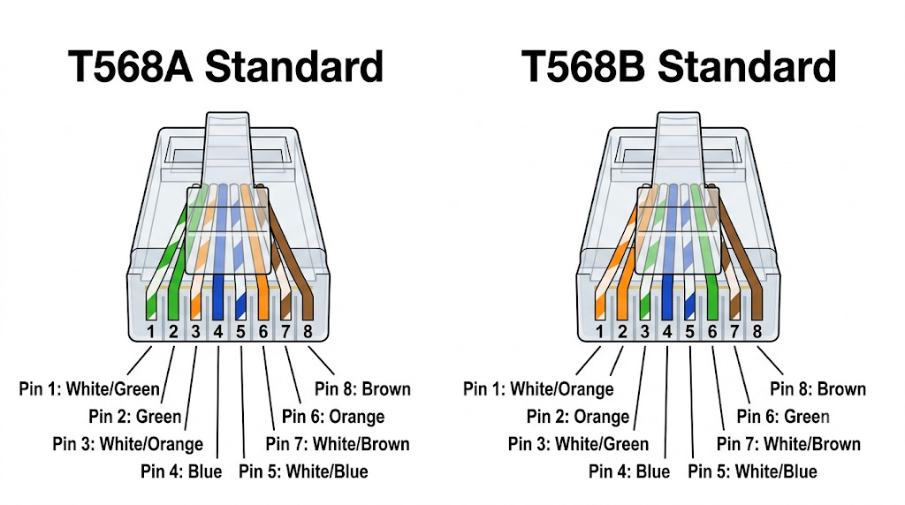

Create a table comparing the key specifications of Ethernet standards 10BASE-T, 100BASE-TX, and 1000BASE-T, including speed, cable type, maximum cable length, and connector type.
Ans :
Specification | 10BASE-T | 100BASE-TX | 1000BASE-T
Common Name | Standard Ethernet | Fast Ethernet | Gigabit Ethernet
IEEE Standard | 802.3i | 802.3u | 802.3ab
Maximum Data Speed | 10 Mbps | 100 Mbps | 1 Gbps (1,000 Mbps)
Minimum Cable Type | Category 3 (Cat3) UTP | Category 5 (Cat5) UTP | Category 5e (Cat5e) UTP
Wire Pairs Used | 2 pairs (4 wires) | 2 pairs (4 wires) | 4 pairs (8 wires simultaneously)
Max Cable Distance | 100 meters (328 ft) | 100 meters (328 ft) | 100 meters (328 ft)
Connector Type | RJ-45 | RJ-45 | RJ-45

Given a scenario where you need to connect two laptops directly using Ethernet, explain which cable (straight-through or crossover) you would use and why.<br><br><em><strong>Hint:</strong> Think about how transmit and receive pairs are wired in each cable type.</em>
Ans :

To connect two laptops directly using an Ethernet cable, the type of cable required depends on the age and hardware capabilities of the laptops' network interface cards (NICs):

1. Modern Laptops (Built within the last 10–15 years)
- Cable Needed: Any standard Straight-Through Ethernet Cable (or a Crossover cable).

- Why: Modern network cards feature Auto-MDI/MDI-X (Automatic Medium Dependent Interface Crossover). The hardware automatically detects that it is connected directly to another host rather than a switch or router and electronically swaps the internal transmit (TX) and receive (RX) lines inside the port. Because of this, a regular straight-through patch cable works effortlessly.

2. Legacy Laptops (Older networking hardware without Auto-MDI/MDI-X)
- Cable Needed: Crossover Cable

- Why: Ethernet ports use specific pin pairs for transmitting data and receiving data:

  - Pin 1 & 2: Transmit ($TX+$ / $TX-$)

  - Pin 3 & 6: Receive ($RX+$ / $RX-$)

If you use a standard Straight-Through cable (where Pin 1 connects to Pin 1, Pin 2 to Pin 2, etc.), both laptops will attempt to send data on Pins 1 & 2 simultaneously into each other's transmit pins, resulting in a signal collision and zero communication.

A Crossover cable physically swaps the pairs—wiring Pin 1 & 2 on one end to Pin 3 & 6 on the other end (effectively joining T568A on one end with T568B on the other). This ensures Laptop A's Transmit pins connect directly into Laptop B's Receive pins, allowing bidirectional communication.

List three real-world devices in your home or college that use Ethernet connections, and for each, specify the likely Ethernet standard (e.g., 100BASE-TX, 1000BASE-T) they support.
Ans ;
- Smart TV (e.g., Living Room TV)

  - Likely Ethernet Standard: 100BASE-TX (Fast Ethernet)

  - Why: Surprisingly, almost all modern Smart TVs stick to 100 Mbps Fast Ethernet ports. Standard 4K video streams only require around 15–25 Mbps bandwidth, making 100BASE-TX more than sufficient while saving manufacturing costs.

- Desktop PC / Gaming Console (e.g., PS5, Xbox Series X, or College Lab PC)

  - Likely Ethernet Standard: 1000BASE-T (Gigabit Ethernet)

  - Why: Computers and gaming consoles regularly download multi-gigabyte game updates, process massive local file transfers, and stream low-latency online multiplayer games, requiring up to 1,000 Mbps speeds over 4 twisted pairs.

- Single-Board Computer / Network Server (e.g., Raspberry Pi 4 or College Lab Server)

  - Likely Ethernet Standard: 1000BASE-T (Gigabit Ethernet)

  - Why: Devices used as local media servers (NAS), IoT gateways, or lab testing nodes depend on full Gigabit throughput to handle simultaneous connections across local networks without bottlenecking data flow.

